Screencast 5-1

Views. Editable views.

# Views in a database

used_cars view - cars with mileage over 50k

CREATE view used_cars AS

SELECT * FROM car WHERE mileage > 50000

select * from used_cars

# Remove a view

drop view used_cars

# Read-only and updatable views

popular_car_1 - cars with 2+ reservations

create view popular_car_1 as

select car.cid , car.clsid , car.make, car.mileage

from car join res using (cid)

group by 1, 2, 3, 4

having count(*) >=2;

An updatable version of this view is shown below:

create view popular_car_2 as

select car.cid , car.clsid , car.make, car.mileage

from car

where car.cid in (select res.cid

from res

group by 1

having count(*) >=2);

Virtual PK in DBeaver for the editable view interface can be found on figure 1:

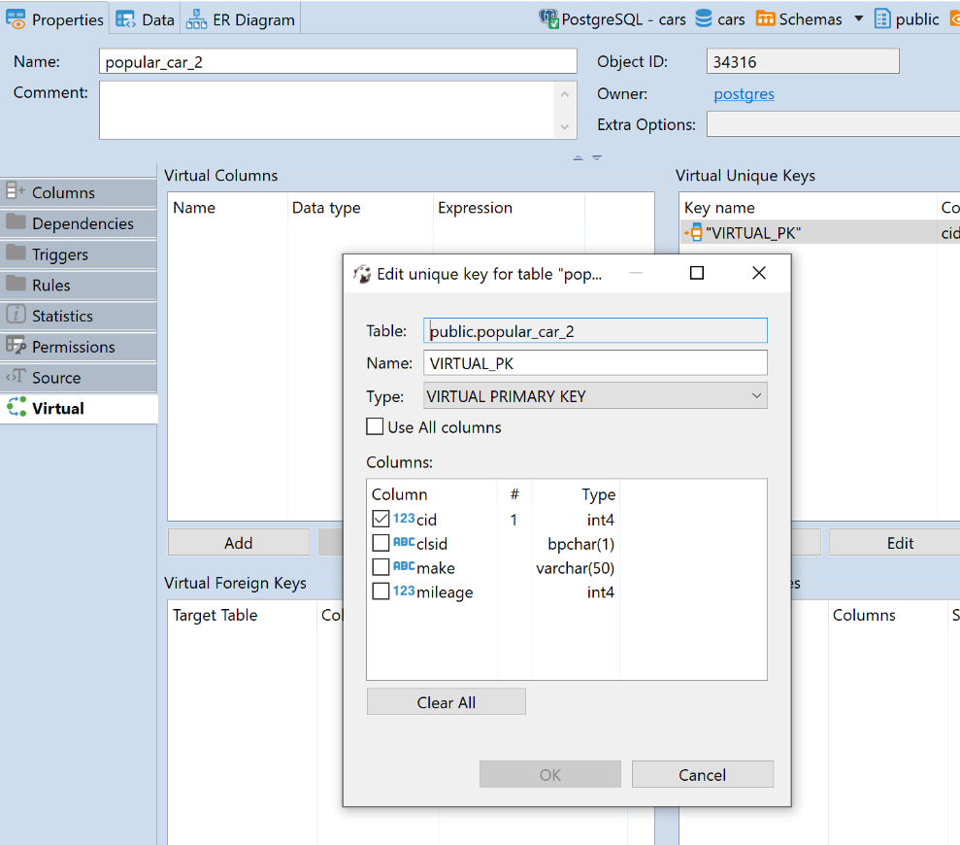

Figure Virtual PK